**Modern Japanese Photography**

Modern photography in Japan incorporated varied styles that sometimes contradicted in aesthetic approaches and intentions. Fundamentally there were two broad trends. The first encompassed innovative movements including New Photography (*Shinkō shashin*), Constructivism (*Kōsei-ha*), and Surrealism (*Chōgenjitsushugi*), as well as new techniques like photomontage and photograms. The second focused on a more realistic expression conveyed through straight photography. The latter was particularly used to capture prewar city life during a period that witnessed broad economic prosperity, an explosive growth in the urban population, and a flourishing urban middle class. However, realist photography was also used extensively in wartime propaganda of the late 1930s and 1940s, while photojournalism was the dominant style of the 1950s. Many photographers experimented with more than one style. Publications were key to the spread of modern photography, with journals, exhibition catalogues, and photographic books all significant methods of circulating images and information. Foreign ideas also frequently had a significant impact on shaping the Japanese photography world, as conveyed through photo periodicals and traveling exhibitions.

The idea of photography as artistic expression rather than for practical purposes emerged in the 1890s. Inspired by an 1893 Tokyo exhibition of Pictorialist works by London Camera Club members, amateur photographers began utilising alternative printing processes to create images that mimicked ink painting, a style popular into the 1920s. Though Pictorialism is considered a precursor to modernism, Fukuhara Shinzō’s (福原信三) influence on later Pictorialism embodied modernist philosophy. From 1922, Fukuhara wrote extensively about his key concept *Hikari to sono kaichō* (Light with its Harmony), arguing that instead of relying on print manipulation, photography should employ its fundamental formal characteristics – light and shade – to express the artist’s inner world.

Strong shifts towards objective modern photography occurred in the mid-1920s with the emergence of New Photography. The Bauhaus and German New Objectivity (*Neue Sachlichkeit*) were key in shaping this movement. Images by artists like Laszlo Moholy-Nagy, Man Ray, and Albert Renger-Patzsch appeared in photo magazines including *Asahi Camera* and *Photo Times* and were displayed in the seminal 1931 ‘Doitsu Kokusai Idō Shashin-ten’ (German International Traveling Photography Exhibition), derived from the 1929 ‘Film und Foto’ exhibit in Stuttgart. Inspired by these works, Japanese photographers embraced what they called the New Realism, an approach diametrically opposed to Pictorialist romanticism. They produced images emphasising the camera’s mechanical capabilities, celebrating modern technology through abstract and mechanized form. Horino Masao (堀野正雄) was one of the best-known photographers to work with this new machine aesthetic. His seminal book *Kamera. Me x tetsu. Kōsei* (*Camera. Eye x Steel. Composition,* 1932) exemplified the movement, employing oblique angles and shifting vantage points to showcase urban steel construction.

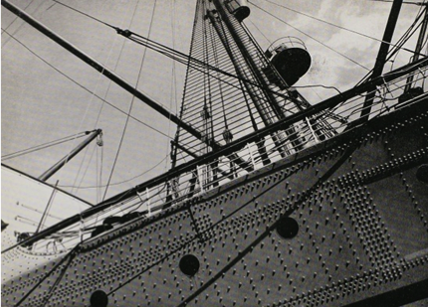

Horino Masao, from *Kamera. Me x tetsu Kösei*, (*Camera, Eye x Steel. Composition*, 1932), Tokyo-to Shashin Bujutstukan (Tokyo Metropolitan Museum of Photography.)

New Photography also encompassed other techniques beyond machine aesthetics, including multiple exposure, macro-photography, and photograms. Although the movement’s original impetus was objectivity, it eventually included more subjective artistic expressions as well. The movement’s core ideas were promoted in the periodical *Kōga* (Light Pictures), launched by Nojima Yasuzō (野島康三), Nakayama Iwata (中山岩太), and Kimura Ihee (木村伊兵衛 ) in 1932. Although it only ran for eighteen months, *Kōga* became the most influential platform for the spread of modern photography. The inaugural issue included the essay ‘Return to photography’ (‘Shashin ni kaere’) by Ina Nobuo (伊奈信男), widely considered as a manifesto for the modern photography movement. Ina wrote that photography, as an artistic form relying on a mechanical apparatus, was the art best suited to contemporary life. But he also commented that as social beings, photographers had a responsibility to engage with society, not merely document it abstractly. The founders of *Kōga* ultimately produced differing versions of modern photography that extended beyond the initial parameters of New Photography, with Nojima best known for innovative portraits and nudes, Kimura for candid street photography, and Nakayama for experimental imagery including photomontage.

Many of the most provocative ideas emerged in Kansai (Western Japan), where artists favored the term avant-garde (*zen’ei*) rather than new. Here, photography clubs played a particularly important role. Amateur groups such as the Ashiya Photography Club (founded by Nakayama Iwata) and the Naniwa Photography Club engaged in a wide range of photographic experimentation. Naniwa members included Yasui Nakaji (安井仲治) and Koishi Kiyoshi (小石清); Koishi’s innovative series of photomontages *Shoka Shinkei* (Early Summer Nerves, 1933) is regarded as one of the most important modern photo-books. Though not considered part of New Photography, there was also a short-lived Constructivist movement in Kansai in the mid-1920s, pioneered by Fuchikami Hakuyō (淵上白陽) in Kobe, who advocated emphasizing the abstract beauty of form in his publication *Hakuyō* (est. 1922). In the late 1930s, Kansai photographers were also more active in exploring Surrealism than those in Tokyo. Yamamoto Kansuke (山本悍右), originally part of the Nagoya Photo Avant-Garde, was among the key artists of this movement.

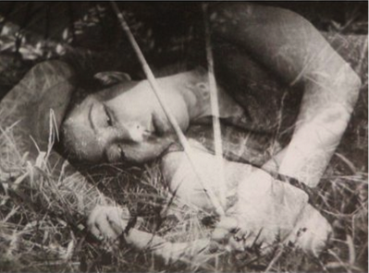

Koishi Kiyoshi, from *Shoka Shinkei* (*Early Summer Nerves*, 1933), Tokyo-to Shashin Bujutstukan (Tokyo Metropolitan Museum of Photography.)

Ina Nobuo’s ideas ultimately helped usher in a shift towards socially engaged realism in the 1930s. This trend was particularly dominant in the Tokyo area, where artists such as Kuwabara Kineo (桑原甲子雄)extensively documented Tokyo street life. Natori Yōnosuke (名取洋之助), influenced by his experience as a photojournalist in Germany, was another key figure promoting straight photography. In 1933 Natori helped form the Nippon Kōbō (Japan Studio), which published the magazine *Nippon* from 1934. Issued in multiple Western languages, this was a propaganda vehicle that used photojournalism to showcase positive aspects of Japanese culture as the Japanese empire became increasingly militaristic. It included images by Horino Masao, Domon Ken (土門拳), and Watanabe Yoshio (渡辺義雄). Other propaganda publications including *Shashin shuhō* (Photography Weekly) relied on journalistic images as well, but also incorporated photomontage. Examples of dynamic modern graphic effects utilising photos can be found in these periodicals*.* By the late 1930s, avant-garde photography was viewed with suspicion and subjected to censorship, and realistic photography was the norm, a trend that continued through the immediate postwar period. Photojournalism remained prevalent in the 1950s, although strains of Surrealism lingered and artists like Ueda Shōji (植田正治) also worked independently. Significant figures embodying straight photography in this period include Hamaya Hiroshi (濱谷浩 ) and Hayashi Tadahiko (林忠彦). By the end of the decade, young photographers like Narahara Ikkō (奈良原 一高), Tōmatsu Shōmei (東松照明), and Hosoe Eikoh (細江英公) would take Japanese photography in an entirely different direction with their innovative ideas.

**References and Further Reading**

Kaneko, Ryūichi (2001). *Modern Photography in Japan 1915-1940*, San Francisco: Friends of Photography.

Kuwahara Kineo, et al. (1986). *Kindai shashin no gunzō* (The Modern Photography Movement in Japan). Volume 3 of *Nihon shashin zenshū* (The Complete History of Japanese Photography), Tokyo: Shōgakkan.

Tokyo-to Shashin Bijutsukan (1995). *Kindai shashin no seiritsu to tenkai (The Founding and Development of Modern Photography in Japan)*, Tokyo: Tokyo Metropolitan Museum of Photography.

Tucker, Anne Wilkes, et al, (2003). *The History of Japanese Photography*, New Haven: Yale University Press in association with the Museum of Fine Arts Houston.